**K L UNIVERSITY**

**FRESHMAN ENGINEERING DEPARTMENT**

**A Project Based Lab Report**

**On**

**TRAIN TICKET**

**SUBMITTED BY:**

I.D NUMBER NAME

160030081 A. PAVAN KUMAR

160030094 B. MOHANA

160030135 B. HIMAJA

160030159 B. NAVYA

**UNDER THE ESTEEMED GUIDANCE OF**

**Dr. G. MURUGAN**

**ASSISTANT PROFESSOR**



**KL UNIVERSITY**

Green fields, Vaddeswaram – 522 502

Guntur Dt., AP, India.

**DEPARTMENT OF BASIC ENGINEERING SCIENCES**



**CERTIFICATE**

This is to certify that the project based laboratory report entitled “TRAIN TICKET” submitted by Mr./Ms**. B. NAVYA** bearing Regd. No. 160030094 to the **Department of Basic Engineering Sciences, KL University** in partial fulfillment of the requirements for the completion of a project based Laboratory in “C PROGRAMMING & DATA STRUCTURES-2 LAB”course in I B Tech II Semester, is a bonafide record of the work carried out by him/her under my supervision during the academic year 2016 – 2017.

PROJECT SUPERVISOR HEAD OF THE DEPARTMENT

G.MURUGAN Dr. D.HARITHA

**ACKNOWLEDGEMENTS**

It is great pleasure for me to express my gratitude to our honorable President **Sri. Koneru Satyanarayana**, for giving the opportunity and platform with facilities in accomplishing the project based laboratory report.

I express the sincere gratitude to our principal **Dr. A. Anand Kumar** for his administration towards our academic growth.

I express sincere gratitude to our Coordinator **Dr. D.Haritha** for her leadership and constant motivation provided in successful completion of our academic semester.

I record it as my privilege to deeply thank our pioneer **Dr. D.Haritha**, HOD-BES for providing us the efficient faculty and facilities to make our ideas into reality.

I express my sincere thanks to our project supervisor DR.G.MURUGAN for his/her novel association of ideas, encouragement, appreciation and intellectual zeal which motivated us to venture this project successfully.

Finally, it is pleased to acknowledge the indebtedness to all those who devoted themselves directly or indirectly to make this project report success.

Name: B. NAVYA

Regd . No: 160030159

**ABSTRACT**

People usually travel in trains in our country. As the number of people who want to plan ahead and travel with reserved seats is increasing, demand for an efficient system of booking tickets is also increasing. The manual system of booking tickets with long queues is long gone.

In this project, we attempt to write a program that would display to a passenger, details like its times and places of arrival and departure, fare for respective classes i.e. first, second and third. One could even avail concessions if possible in this process. From these displayed options one could select a train of their convenience. After the ticket is booked a ticket is displayed which contains all the details of train.

This code is written in C language and graphics are added to it through VDU to make this more interesting. Booking tickets in this manner is far more efficient than manually doing it.

**INDEX**

**S.NO TITLE PAGE NO**

1. Introduction 6
2. Aim of the Project 7

2.1 Advantages & Disadvantages

2.2 Future Implementation

1. Software & Hardware Details 8
2. Data Flow Diagram 9
3. Algorithm for each module 11
4. Implementation 15
5. Integration and System Testing 25
6. Conclusion 27

**INTRODUCTION**

This system is basically concerned with the reservation and cancellation of railway tickets to the passengers. The need of this system arose because as is the known fact that India has the largest railway network in the whole of the world and to handle it manually is quite a tough job. By computerizing it, we will be able to overcome many of its limitations and will be able to make it more efficient. The handling of data and records for such a vast system is a very complex task if done manually but it can be made much easier if the system is computerized. To be more specific, our system is limited in such a way that a train starting from a particular source will have a single destination The basic functions being performed by our system are :

1. RESERVATION MANAGEMENT

2. FARE MANAGEMENT

3. TIMETABLE MANAGEMENT

**AIM OF THE PROJECT**

The main objective of Railway Ticket Reservation system is to enhance and upgrade the existing system by increasing its efficiency and effectiveness. The software improves the working methods by replacing the existing manual system with the computer-based system.

**Advantages:-**

The software Railway Ticket Reservation system has a very user-friendly interface. Thus the users will feel very easy to work on it. The software provides accuracy along with a pleasant interface.Make the present manual system more interactive, speedy and user friendly.

**Disadvantages:-**

This is a basic way of using computers in booking of tickets.

This can be further developed and its time complexity can be reduced.

**Future enhancements:-**

Future enhancements can be made so that it takes lesser amount of time and space. More number of options can also be included.

**SYSTEM REQUIREMENTS**

* **SOFTWARE REQUIREMENTS:**

The major software requirements of the project are as follows:

Language : Turbo-C

Operating system**:** Windows XP or later.

* **HARDWARE REQUIREMENTS:**

The hardware requirements that map towards the software are as follows:

RAM : 8 GB

Processor : I5

**DATA FLOW DIAGRAM**

READ I,j,AMOUNT,TOTAL AMOUNT

If

I=1

If

I=3

ENTER YOUR COMPARTMENT i

1.A.C

2.GENERAL

3. PASSENGER

ENTER YOUR TRAIN NUMBER

If

I=2

no

No

Yes yes yes

Print the amount

Do you want concession

Yes are no

If

yes

yes

Concession details

1.SENIOR CITIZEN

2.LADIES QUOTA

3.HANDICAP

If

J=3

If

J=2

if

J=1

S

No No

Print the total amount

Total cost=amount-j(cost)

Yes yes yes

Print amount

**ALGORITHM**

Step-1: Start

Step-2: Read the type of citizens

Step-3: Read the proof is there or not and the type of concession

Step-4: if (q==1)

Step-5: calculate f=f-f*0.2

Step-6: otherwise

Step-7: if(q==2)

Step-8: calculate f=f-f*0.1

Step-9: otherwise

Step-10: if(q==2)

Step-11: calculate f=f-f*0.25

Step-12: otherwise

Step-13: f=f

Step-14: display “concession invalid” and return “f”

Step-15: Read the n , c , f , d, gd=DETECT ,gm values

Step-16: display “WELCOME TO INDIAN RAILWAYS”

Step-17: Read the train code, train name , travel from where to where, arrival

and departure time

Step-18: select the train code and display the value of “n”

Step-19: check whether case= 18463 then go to step 20

Step-20: Read it is 1.A/C or 2.sleeper or 3. General

Step-21: if(c=1) then f=2300

Step-22: display 1 to “concession valid”

Step-23: otherwise 0

Step-24: if (d=1)

Step-25: f= concession(f) and display “f”

Step-26: if(c=2) then f=1500

Step-27: then go to step 22, step 23,step 24,step 25

Step-28: if(c=3) then f=1200

Step-29: then go to step 22, step 23,step 24,step 25

Step-30: otherwise

Step-31: if( f=0) then display “wrong entry”

Step-32: display train code : 18463,train name: PRASANTHI EXP , travel from BHUBANESWAR to BANGALORE , arrival : 05:30 and departure :12:00

Step-33: if(f!=0) then display “f”

Step-34: other wise

Step-35: display “booked failed”

Break

Step-36: check whether case= 12805 then go to step 20

Step-37: if(c==1) then f=2300

Step-38: then go to step 22, step 23,step 24,step 25

Step-39: if(c==2) then f=1500

Step-40 : then go to step 22, step 23,step 24,step 25

Step-41: if(c==3) then f=1000

Step-42: then go to step 22, step 23,step 24,step 25

Step-43: otherwise then go to step 31

Step-44: display train code : 12805,train name: JANMABHUMI EXP , travel from SECUNDERABAD TO:VIZAG , arrival : 07:10 and departure :07:30

Step-45: then go to step-33,step-34.step-35

Step-46: check whether case= 12713 then go to step 20

Step-47: if(c==1) then f=2000

Step-48: then go to step 22, step 23,step 24,step 25

Step-49: if(c==2) then f=1200

Step-50: then go to step 22, step 23,step 24,step 25

Step-51: if(c==3) then f=900

Step-52: then go to step 22, step 23,step 24,step 25

Step-53: otherwise then go to step 31

Step-54: display train code : 12713,train name: SATAVAHANA EXP , travel from SECUNDERABAD to VIJAYAWADA , arrival : 04:15 and departure: 09:50

Step-55: then go to step-33,step-34.step-35

Step-56: check whether case= 12712 then go to step 20

Step-57: if(c==1) then f=1200

Step-58: then go to step 22, step 23,step 24,step 25

Step-59: if(c==2) then f=900

Step-60: then go to step 22, step 23,step 24,step 25

Step-61: if(c==3) then f=500

Step-62: then go to step 22, step 23,step 24,step 25

Step-63: otherwise then go to step 31

Step-64: display train code : 12712,train name: PINKINI EXP , travel from CHENNAI to VIJAYAWADA, arrival : 02:10 and departure : 09:10

Step-65: then go to step-33,step-34.step-35

Step-66: end

**IMPLEMENTATION**

#include<stdio.h>

#include<conio.h>

#include<graphics.h>

int concession(int f)

{

int q;

setcolor(4);

setbkcolor(9);

printf("\n1.SENIOR CITIZEN\n2.LADIES QUOTA\n3.HANDICAP");

printf("\nPROOF MANDATORY");

printf("\nSelect the type of cocession:");

scanf("%d",&q);

if(q==1)

f=f-f*0.2;

else if(q==2)

f=f-f*0.1;

else if(q==3)

f=f-f*0.25;

else

{

f=f;

printf("\nconcession invalid");

}

return f;

}

void main()

{

int n,c,f,d,gd=DETECT,gm;

clrscr();

initgraph(&gd,&gm,"c:\\turboc3\\bgi");

setbkcolor(3);

setcolor(8);

printf("\n\t\t\tWELCOME TO INDIAN RAILLWAYS");

printf("\nTRAIN CODE TRAIN NAME FROM TO ARR. DEP.");

printf("\n18463 PRASHANTI EXP BHUBANESWAR BANGALORE 05:30 12:00");

printf("\n12805 JANMABHUMI EXP SECUNDERABAD VIZAG 07:10 07:30");

printf("\n12713 SATAVAHANA EXP SECUNDERABAD VIJAYAWADA 04:15 09:50");

printf("\n12712 PINAKINI EXP CHENNNAI VIJAYAWADA 02:10 09:10");

printf("\nEnter 0 to exit\nSelect the train code carefully:");

scanf("%d",&n);

switch(n)

{

case 18463: printf("\n1:A/C\n2:sleeper\n3:general\nEnter no.:");

scanf("%d",&c);

if(c==1)

{

f=2500;

printf("print 1 to avail concession else 0:");

scanf("%d",&d);

if(d==1)

f=concession(f);

printf("Fare=%d",f);

}

else if(c==2)

{

f=1800;

printf("print 1 to avail concession else 0:");

scanf("%d",&d);

if(d==1)

f=concession(f);

printf("Fare=%d",f);

}

else if(c==3)

{

f=1200;

printf("print 1 to avail concession else 0:");

scanf("%d",&d);

if(d==1)

f=concession(f);

printf("Fare=%d",f);

}

else

{

f=0;

printf("\nWrong Entry");

}

clrscr();

printf("\nTRAIN CODE:18463\nTRAIN NAME:PRASANTHI EXP\nFROM:BHUBANESWAR TO:BANGALORE");

printf("\nARR:05:30 DEP:12:00");

if(f!=0)

printf("\nFARE=%d",f);

else

printf("\nBOOKING FAILED");

break;

case 12805: printf("\n1:A/C\n2:sleeper\n3:general\nEnter no.:");

scanf("%d",&c);

if(c==1)

{

f=2300;

printf("print 1 to avail concession else 0:");

scanf("%d",&d);

if(d==1)

f=concession(f);

printf("Fare=%d",f);

}

else if(c==2)

{

f=1500;

printf("print 1 to avail concession else 0:");

scanf("%d",&d);

if(d==1)

f=concession(f);

printf("Fare=%d",f);

}

else if(c==3)

{

f=1000;

printf("print 1 to avail concession else 0:");

scanf("%d",&d);

if(d==1)

f=concession(f);

printf("Fare=%d",f);

}

else

{

f=0;

printf("\nWrong Entry");

}

clrscr();

printf("\nTRAIN CODE:12805\nTRAIN NAME:JANMABHUMI EXP\nFROM:SECUNDERABAD TO:VIZAG");

printf("\nARR:07:10 DEP:07:30");

if(f!=0)

printf("\nFARE=%d",f);

else

printf("\nBOOKING FAILED");

break;

case 12713: printf("\n1:A/C\n2:sleeper\n3:general\nEnter no.:");

scanf("%d",&c);

if(c==1)

{

f=2000;

printf("print 1 to avail concession else 0:");

scanf("%d",&d);

if(d==1)

f=concession(f);

printf("Fare=%d",f);

}

else if(c==2)

{

f=1200;

printf("print 1 to avail concession else 0:");

scanf("%d",&d);

if(d==1)

f=concession(f);

printf("Fare=%d",f);

}

else if(c==3)

{

f=900;

printf("print 1 to avail concession else 0:");

scanf("%d",&d);

if(d==1)

f=concession(f);

printf("Fare=%d",f);

}

else

{

f=0;

printf("\nWrong Entry");

}

clrscr();

printf("\nTRAIN CODE:12713\nTRAIN NAME:SATAVAHANA EXP\nFROM:SECUNDERABAD TO:VIJAYAWADA");

printf("\nARR:04:15 DEP:09:50");

if(f!=0)

printf("\nFARE=%d",f);

else

printf("\nBOOKING FAILED");

break;

case 12712: printf("\n1:A/C\n2:sleeper\n3:general\nEnter no.:");

scanf("%d",&c);

if(c==1)

{

f=1200;

printf("print 1 to avail concession else 0:");

scanf("%d",&d);

if(d==1)

f=concession(f);

printf("Fare=%d",f);

}

else if(c==2)

{

f=900;

printf("print 1 to avail concession else 0:");

scanf("%d",&d);

if(d==1)

f=concession(f);

printf("Fare=%d",f);

}

else if(c==3)

{

f=500;

printf("print 1 to avail concession else 0:");

scanf("%d",&d);

if(d==1)

f=concession(f);

printf("Fare=%d",f);

}

else

{

f=0;

printf("\nWrong Entry");

}

clrscr();

printf("\nTRAIN CODE:12712\nTRAIN NAME:PINKINI EXP\nFROM:CHENNAI TO:VIJAYAWADA");

printf("\nARR:02:10 DEP:09:10");

if(f!=0)

printf("\nFARE=%d",f);

else

printf("\nBOOKING FAILED");

break;

default : printf("\nWRONG ENTRY");

}

getch();

closegraph();

}

**INTEGRATION AND SYSTEM TESTING**

OUTPUTS

Screen Shots:

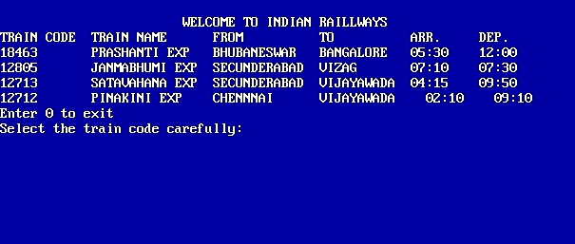

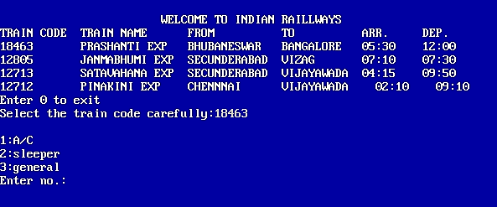

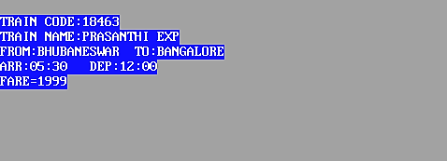

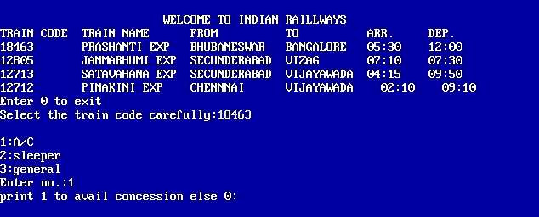

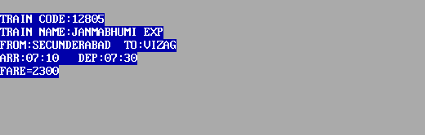

**CONCLUSION**

This project is an attempt at making a program in C language which displays the available trains list along with their starting and ending stations. Train arrival and departure times are also displayed. From this list, a required train can be chosen by the passenger. If any concession is available, it can also be availed.